The Regional Economic Impact of the Civil Rights Act of 1964

Gavin Wright[1]*

**Stanford University**

**Prepared for BU Law Conference: The Civil Rights Act at 50**

Introduction 101

I. Public Accommodations 103

II. Racial Discrimination in Labor Markets: The Regional Context of Title VII 106

III. Black Economic Gains Under Title VII 108

IV. Regional Persistence After 1980 116

Conclusion 120

Introduction

The Civil Rights Act of 1964[2] was a genuine landmark, “the most important piece of legislation passed by Congress in the twentieth century,” according to one recent history.[3] But did the Act have *economic* as well as moral and legal significance? If there were important economic gains for African-Americans during the Civil Rights era, can we attribute these with confidence to federal legislation, as opposed to ongoing progress in schooling and racial attitudes? If the Act was “an idea whose time has come”[4] as Senator Dirksen suggested, then perhaps it merely ratified and facilitated a process already underway.

This article argues that the Civil Rights Act did indeed precipitate new economic advances for African Americans in income, occupational status, and educational attainment. But this statement is subject to two stipulations that are not always clearly recognized. First, these gains were only realized through a combination of grassroots mobilization, legal activism, and resolute enforcement by the executive branch and the courts—much of which extended the meaning and implications of the Act beyond what might have been understood from the explicit language of the 1964 law. Despite this element of temporal contingency, the Act still deserves prime credit for initiating historical change. Its passage broke the back of the southern filibuster and sent a powerful signal that a new era in race relations was dawning.

The second stipulation is that most of the economic gains from the Civil Rights Act occurred in the South. This geographic disparity was partly a matter of design, since the Act was written with the South primarily in mind. It also reflects the relatively low economic starting point for black southerners in 1964, and the more readily targeted explicit segregation systems that characterized workplaces in the South. But because the southern advantage for African-Americans has persisted well beyond the period of intense legal enforcement, its underlying basis is by no means as obvious as may appear at first glance.

This Article concentrates on public accommodations under Title II[5] and private employment under Title VII[6] of the 1964 Civil Rights Act. Thus it makes no claim to completeness in considering all of the potential economic consequences of the Act. The 1964 Act said nothing about housing discrimination, and its mild provisions on voter registration under Title I[7] and Title VIII[8] had little effect until amended and expanded by the Voting Rights Act of 1965.[9] In addition, Title IV[10] empowered the Attorney General to file suits to enforce school desegregation, while Title VI[11] allowed federal agencies to withhold funding from any institution that failed to comply with the agency’s anti-discrimination requirements. These provisions were important in accelerating the pace of school desegregation in the South, especially when combined with the 1965 passage of the Elementary and Secondary Education Act,[12] which dramatically increased federal funding for public schools.[13] But school desegregation is a distinct and complex historical topic, albeit one with significant economic content. It will be set aside here for another occasion.

I. Public Accommodations

This section considers public accommodations and Title II as economic phenomena. It may appear that this topic is more social than economic, but the economic content is significant not only because of both the hardships and constraints on mobility imposed on African-Americans, as well as the implications of desegregation for commercial activity, but also because of the basis on which constitutionality was settled, using the Commerce Clause as opposed to the Fourteenth Amendment. This issue was regional virtually by definition, because nearly all non-southern states (and most cities) had public accommodation anti-discrimination laws by 1964, while no southern state came close to doing so.

Contrary to much casual commentary, gaining access to public accommodations was not a matter of abolishing de jure segregation. Because federal courts after *Brown v. Board of Education*[14] consistently ruled that state-enforced racial discrimination was illegal, most laws *requiring* segregation had been repealed by the 1960s.[15] Nor was it a case of farsighted business groups taking the lead in abolishing archaic racial restrictions in pursuit of their own self-interest. Business acquiescence was reluctant, coming only after heavy economic losses from years of protest, primarily in the forms of sit-ins and boycotts. Although the racial attitudes of managers undoubtedly played a role, their opposition to desegregation was fundamentally economic: the fear that accepting black customers would result in the loss of white customers. When asked in late 1959 by James Lawson and others to begin serving African Americans, Nashville department store owners Fred Harvey and John Sloan declined, saying they would lose more business than they would gain.[16] Business fears operated not just at the level of individual firms but often for an entire downtown area. Thus the owner of Meyer’s Department Store in Greensboro predicted that desegregation would make “a kind of ghetto out of this section of the city.”[17]

Throughout this period, the legal issues were cloudy, with both sides appealing to competing and long standing common-law traditions. Although many cases against protesters were dismissed on narrow grounds, the Supreme Court never issued a definitive ruling on the core state action question.[18] Title II of the Civil Rights Act was crucial in bringing resolution to this hotly contested matter.[19]

By the summer of 1963, merchant groups in most major metropolitan areas had made their peace with the protesters, discovering that white customer reaction was far milder than anticipated, and that desegregation actually proved to be a good business move.[20] Despite these successful local settlements, it soon became clear that a purely voluntary approach to the problem would not be adequate. In November 1963, a memo from Assistant Attorney General Louis Oberdorfer acknowledged, “Reports of progress in desegregation of privately owned public facilities show virtually no breakthroughs since the middle of October . . . very little change is now taking place.”[21] Worse yet, partial desegregation often seemed only to make the situation worse. In a follow-up memo Oberdorfer noted the “curious patchwork pattern” that had emerged in which most lunch counters were integrated but not restaurants, theaters but not drive-ins, and so on.[22] The unevenness of outcomes generated strong feelings of inequity on the part of businesses and threatened to unravel existing agreements. Recalling the period in later years, Mayor Ivan Allen of Atlanta reported: “Everything I had tried in those areas [hotels and restaurants] had failed. There had been endless meetings with the hotel and restaurant people over the past three or four years, and no matter what agreement was reached everyone involved would be split in every direction.”[23]

Title II enacted a clear, bright-line principle with virtually universal application. The shift in assessments of political feasibility was remarkably rapid, surprising many veteran observers. The reason for the swing, however, is not difficult to identify. Behind the scenes, the administration was hearing from national drug and variety store chains, who recognized that limited, narrowly defined desegregation would perpetuate uncertainty and could put complying firms at a competitive disadvantage. In the House of Representatives, which fended off all efforts to water down Title II, debate was marked by the virtual absence of organized business opposition.[24]

Nevertheless, the new principle might have been far less effective if not for the active participation of Civil Rights groups (who stood ready to test the new law from the day it went into effect), meaningful enforcement by the Department of Justice, and consistent support from the courts. Civil Rights leaders launched a massive effort to test compliance and seek implementation of Title II within minutes of President Johnson’s signing.[25] Morrison’s, the largest cafeteria chain in the South, announced that it would serve Negroes “rather than buck the Federal Government.”[26] Resistance flared in a number of well-publicized cases, primarily in smaller towns and rural areas that had not seen sit-ins and protests. The Justice Department brought ninety-three cases in the first three years (supplemented by many private suits), serving notice that outright defiance would be prosecuted. By the early 1970s litigation had moved on to socially sensitive areas such as bowling alleys and skating rinks, ultimately bringing almost all of these facilities under Title II coverage, even where a connection to interstate commerce was remote or absent altogether.[27] As public accommodations complaints dwindled, the last attorney general’s report with a section devoted to Title II appeared in 1977.[28]

The speed and relative completeness of the public accommodations revolution may convey the sense that the entire issue was of secondary importance, but this perception is only plausible in retrospect. In its day, this was a hot-button issue. Joseph Singer has noted that many areas of commerce such as retail trade are probably not covered by Title II, even though most Americans (including law professors) assume that they are.[29] The reason for this disjuncture, he argues, is that “the civil rights statutes passed in the 1960s had a revolutionary impact on public attitudes . . . the prevailing social assumption now is that businesses open to the public have no right to exclude customers on the basis of race and that the law backs up that assumption.”[30] The case of public accommodations thus stands as a prime example of social norms transformed by change in the law. Realignment of business interests under political and economic pressure was an important contributor to this outcome.

II. Racial Discrimination in Labor Markets: The Regional Context of Title VII

At the time of the Civil Rights Act, racial discrimination was pervasive in all parts of the country, but the underlying political and economic structures differed markedly by region. Unlike the rest of the country, firms in the South had explicit racial job classifications and segregated “lines of progression.” As with public accommodations, it is misleading to characterize these systems as “de jure” segregation, as very little of this system was codified into law. Even without legal buttress, segregation lines were extremely stable. Donald Dewey, virtually the only white economist at a southern university to devote research to the race issue, reported in the mid-1950s that in most plants, “the racial division of labor . . . remained fixed as far back as anyone can remember.”[31] Segregation served to define and protect racial wage differentials; typically black wages peaked about where the white wage distribution began. Textiles, the region’s largest industry, was an extreme case, in that black workers were almost completely excluded from machine-tending positions, a tradition entrenched since the Civil War.[32] Earlier antidiscrimination efforts such as the wartime Fair Employment Practices Committee and state fair employment laws had some success in improving black employment status, but virtually none in the South.[33]

In the northern states, by contrast, labor market surveys conducted during the 1930s show no evidence of a racial wage gap.[34] Discrimination instead occurred on non-wage margins, such as assignment to hot, grueling, dangerous foundry jobs in the auto industry, or failure to hire altogether. From the 1930s onward, black unemployment rates were persistently higher in northern than in southern states.[35] These regional differences were reflected in the very name of the 1963 March on Washington for Jobs and Freedom, where the twin goals represented the distinct keywords of the southern and non-southern movements.[36]

Early drafts of the Civil Rights Act contained no fair employment section, an omission reversed in response to vigorous lobbying by groups allied in the Civil Rights Coalition. The administration may have felt that it had already addressed the issue through President Kennedy’s 1961 executive order requiring government contractors to take “affirmative action” towards fair employment, and the voluntary Plans for Progress program.[37] But early reports from these programs indicated that “[n]umerical gains are slight.”[38] Political pressures for a federal law that applied to private employers came from both regional branches of the movement, and the resulting Title VII prohibited discrimination in either employment or compensation, adding color, religion, national origin and sex to race as protected categories.

Nonetheless, prevailing expectations for significant progress under the Act were low, because of compromises during the legislative process. The text contained glaring loopholes, such as exemptions for “bona fide” seniority or merit systems, and protection for “professionally developed ability test[s]” so long as they were not “intended or used” to discriminate.[39] More fundamentally, the newly-created Equal Employment Opportunity Commission (“EEOC”) could neither initiate lawsuits nor issue cease-and desist orders. The EEOC was essentially a conciliatory agency for resolving allegations of employment discrimination by individuals. Although these provisions limited enforcement efforts in all regions, Daniel Rodriguez and Barry Weingast argue persuasively that their primary purpose was to protect northern employers against discrimination charges, reflecting a major constituency of the Republican minority whose support was needed to overcome the Southern filibuster in the Senate.[40] Thus the stipulation that employers must exhibit a “pattern or practice” of discrimination seemed to target explicit southern segregation systems as opposed to subtler forms of bias elsewhere. Similarly, the requirement that petitioners must first exhaust remedies under state fair-employment offices was also decidedly regional, since the twenty-eight states that had such commissions were all non-southern.

Like the rest of the Act, Title VII was passed with the South primarily in mind. In light of the structural weaknesses of the enforcement system, however, Title VII might have been of no more consequence than earlier efforts, even in the South. What made this time different were ongoing political mobilization in the South, lawyers aggressively pursuing private discrimination suits, and a federal government responsive to these pressures.

III. Black Economic Gains Under Title VII

Despite the impression of legislative weakness, the economic status of African-Americans began to improve at an accelerated pace after passage of the Civil Rights Act, especially in the South. The discontinuity in relative black incomes around 1965 has been established by several empirical studies.[41] The predominance of the South in these gains has also been confirmed by studies that disaggregate by region.[42] Supplementary confirmation comes from the finding that black employment gains were greater at large employers covered by Title VII relative to others; and that these gains were extended to newly-covered employers when the Act was amended in 1972.[43]

Some recent surveys have conveyed the impression that determining the impact of Title VII on black labor market outcomes is a tough statistical challenge because the near-universality of coverage meant that this was a policy experiment with no control group.[44] The fact of black economic progress, especially in the South, can hardly be denied. But how can we know with confidence that these changes would not have happened anyway in the absence of federal legislation as the result of long-term trends in education and economic development?

Once one recognizes that discriminatory structures in the South were very different than in other parts of the country, the story is not that complicated. Within the South, there is virtually no evidence of any positive pre-trend in relative black incomes or occupational status, nor any weakening of employment segregation, prior to the 1960s. Figure 1 offers some sense of just how abrupt the change was in the important case of the textiles industry. The figures are for South Carolina because only that state tracked industry employment by race on an annual basis. But all indications are that the timing in other textile states was similar. It is true that wages for textile workers were rising in the 1960s so that employers had an incentive to tap into a new source of labor. But Figure 1 shows that earlier episodes of labor-market tightness, including both world wars, had no more than modest transitory effects on black exclusion. During the 1960s, in contrast, the break in industry demand for black labor occurred almost simultaneously in the textile counties of the state, regardless of local demographic or economic conditions.[45] One could hardly ask for a clearer before-and-after test.

**Figure 1**

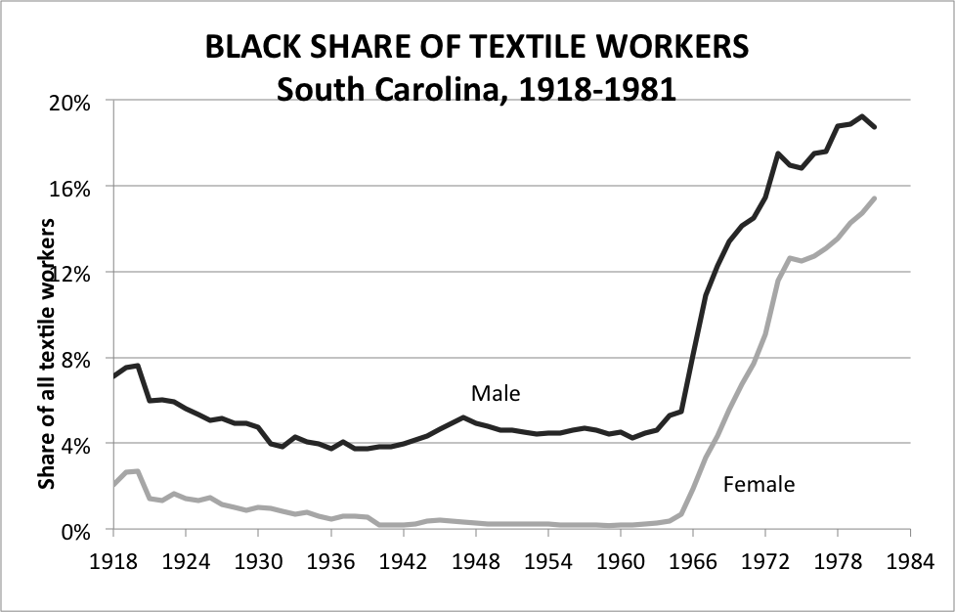

**Source:** South Carolina Department of Labor, Annual Reports, 1918-1982.

It is true that the relative quality of southern black schools had improved from its low point in the 1920s, as measured by such indicators as teacher salaries, pupil-teacher ratios, and the length of the school year.[46] The gains came about through a combination of philanthropic support from outside the region (most prominently the Rosenwald Fund) and NAACP-sponsored litigation to enforce the “equal” part of the *Plessy v. Ferguson*[47] principle.[48] Progress in education was undoubtedly important in facilitating economic change in the 1960s. But econometric analyses that control for years of schooling still show a significant structural break in the mid-1960s. The most striking finding in the study by economists David Card and Alan Krueger is the sharp increase in the *return* to black schooling in that decade, a shift more closely linked to the location of work than of prior schooling.[49] Looking forward from 1964, studies that control for education understate the change associated with Title VII, because of dynamic complementarity between schooling and occupational progress.

Federal Census data show no evidence of progress in southern black occupational status between 1950 and 1960, though in other regions black employment shares drifted upward in such categories as clerical, sales, and skilled blue-collar jobs.[50] Any positive pre-trend was therefore confined to non-southern states. Annual income data from the Current Population Survey confirm this picture of slow progress in the Northeast and Midwest versus stagnation or even retrogression in the South until the 1960s (Figure 2). Despite a decade of robust real wage growth for most Americans, median real income for black male southerners was no higher in 1963 than it had been ten years earlier. For black women, the turning point may have been a year or two earlier, but the pattern was essentially similar. Thus the most that a Title VII-skeptic can claim is that the economic tide for black southerners had begun to turn shortly prior to enactment.

**Figure 2**

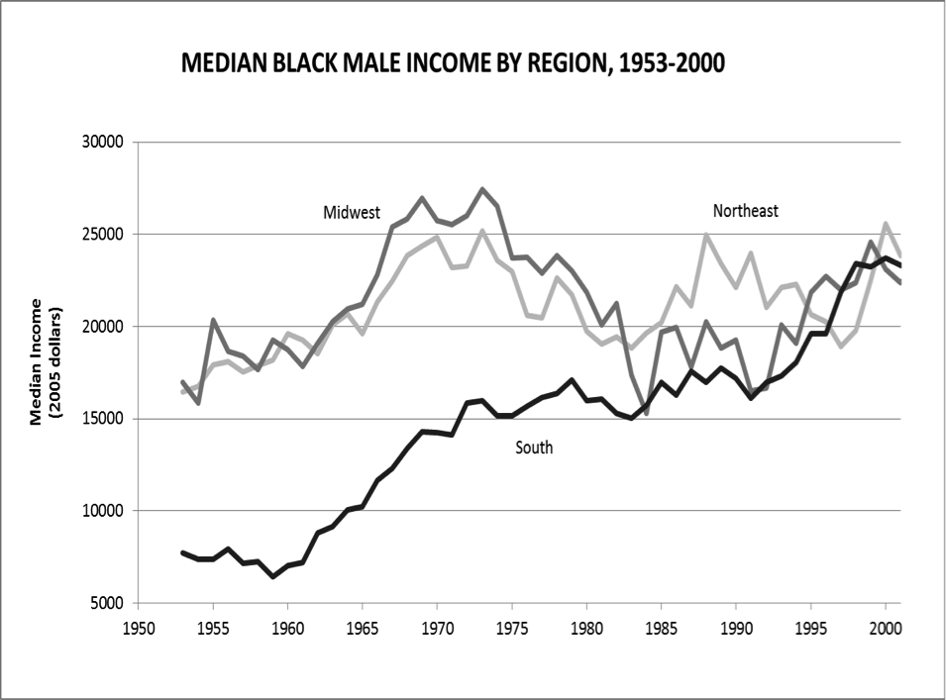

**Source:** U.S. Bureau of the Census. Current Population Survey. Annual Social and Economic Supplements. Historical Income Data. Table P-5.

It would be surprising if there were no signs of southern black progress prior to 1965. The Civil Rights Movement had been pushing for “responsible jobs” for years.[51] Virtually every demand for access to services was coupled with demands for jobs providing those services, as in the Birmingham sandwich boards reading “Don’t buy where you can’t be a salesman.”[52] Civil Rights groups also pressured the federal government to enforce President Kennedy’s 1961 executive order, generating at least some affirmative action efforts on the part of southern contractors, such as Lockheed Aircraft in Marietta, Georgia.[53] Progress under the voluntary Plans for Progress program was disappointingly slow, but it wasn’t zero! The main point is this: virtually all of the incremental progress of the early 1960s came in response to the Civil Rights Movement. One might argue that as a matter of historical causation, it was the Movement itself, rather than Title VII, that deserves the lion’s share of the credit.[54] Yet even on this reading, any pre-Title VII employment gains pale in quantitative comparison to those that came after passage of the Act and the leverage it provided for accomplishing the goals of the Movement.

An additional problem in trying to isolate the effects of Title VII is that in the same year its provisions went into effect (1965), President Johnson issued Executive Order 11,246,[55] requiring government contractors to undertake affirmative action towards nondiscrimination and creating the Office of Federal Contract Compliance (“OFCC”) (later the Office of Federal Contract Compliance Programs (“OFCCP”)) to enforce these rules. Studies have shown that black occupational and employment gains were greater at firms with government contracts, particularly those undergoing compliance reviews.[56] Even controlling for the effects of executive-order compliance, class-action litigation under Title VII is found to have had additional favorable effects on black employment.[57] But clearly both channels were parts of a single federal campaign to expand black employment opportunities. Since the OFCCP, the Justice Department, and the EEOC influenced each other and often worked together, trying to distinguish their separate effects with precision seems futile. The futility of the effort is underscored by considering that all of the tests rely on cross-sectional comparisons between firms directly affected and others. They therefore do not include actions taken by firms in order to avoid or preempt litigation or compliance reviews. In all likelihood, this category comprised the better part of the historical change.

How was it that an enforcement system designed to be weak had such powerful effects, and why were these effects so much larger and more lasting in the South? For the early post-Act years, answers to both questions include the strength of southern grassroots mobilization and legal activism. These pressures fostered an expansive reading of Title VII on the part of the EEOC and in turn by the courts. In the previously all-white southern textiles industry, firms were flooded with job applications from aspiring black workers, encouraged by the EEOC. Floyd Harris, one of the first black textile workers in West Point, Georgia, recalled:

I was active in the social revolution that went on from the fifties, through the sixties and early seventies, so I was aware of what the black leaders were talking about. We wrote the laws and they passed the Civil Rights bill, and I knew that if the federal government made it a law it’d have to be followed. Our management here is smart and they knew it too.[58]

Textile management may have been “smart,” but not many were farsighted enough to see in advance that their interests would be served by racial integration. They did not speak out in favor of Title VII, and when the EEOC held hearings in Charlotte in 1967, employers declined to participate. Managers shared many of the same racial prejudices held by white workers, anticipating that new black hires would undermine work performance. When the experiment was actually tried, however, the typical result was “no discernible difference in productivity” between blacks and whites.[59] By 1969, *The New York Times* reported: “Virtually all of the large companies have begun to preach a doctrine of equal, color-blind employment.”[60]

Other southern industries took longer to integrate, often requiring extensive litigation. But here too, grassroots activism was crucial. The landmark case *Griggs v. Duke Power*[61] originated when a group of janitors in the all-black Labor Department of the Dan River Steam Station submitted a letter requesting transfers to previously white departments when vacancies became available.[62] The janitors had strong incentives to transfer, as the maximum wage earned by any of them was $1.645 per hour, whether or not they had a high school education, while the minimum paid to any white worker (many of whom also did not have a high school degree) was $1.875 per hour.[63] They were informed that standards were being raised and that they were welcome to take the new test, instituted on the same date that Title VII went into effect. The group forwarded their complaint to the EEOC, which attempted conciliation but was essentially snubbed by the firm. Only then did the janitors turn to the NAACP Legal Defense Fund, which assisted them in filing suit. The upshot five years later was a Supreme Court ruling that tests having a disparate impact on minorities could be invalid regardless of intent, unless shown to be related to job performance.[64] *Griggs* and related rulings gave new credibility to EEOC guidelines and impelled far more thoroughgoing change than firms had initially anticipated. Citations to the case rose steadily through the 1970s, peaking in 1980 before declining in the next decade.[65]

Thus, the ongoing Civil Rights Movement shaped an expansive understanding of Title VII that went well beyond what might have been understood from the text itself. Under pressure to produce tangible results, the EEOC moved within its first few years away from its original focus on mediating disputes towards a more “wholesale approach,” targeting industries and metropolitan areas where under-representation was severe, and emphasizing numerical goals for minority employment.[66] The EEOC and the NAACP Legal Defense Fund assisted each other in developing legal theories to support these measures. The EEOC revised its guidelines on testing in 1970, after *Griggs* had been argued in the court of appeals, and the Solicitor General urged the Supreme Court to give great deference to these guidelines.[67] Thus the Court had a well-developed body of theory to draw upon. It has been argued that the combination of strongly-motivated private lawsuits and an ostensibly weak agency exercising persuasive powers was more potent than a more centralized enforcement structure would have been.[68] We can only guess at the historical alternative, but activism clearly made a difference.

For similarly pragmatic reasons, the OFCC moved towards a “numbers-oriented affirmative action approach” in its reviews to determine whether federal contractors were in compliance.[69] A key step was OFCC’s Order 4 in early 1970, which required employers to submit explicit affirmative action plans, including “goals and timetables” specifying how many minorities the contractor would attempt to hire in a specified period.[70] Sociologist Frank Dobbin reports that by the end of the 1970s, the majority of large U.S. firms had adopted explicit antidiscrimination policies, personnel offices, job postings and centralized hiring, promotion and discharge practices. “By the early 1980s,” he writes, “leading firms had troops on hand who were fighting for equal opportunity programs. They had internalized the civil rights movement.”[71] This statement may overstate the level of corporate idealism, but when the Reagan Administration proposed to dismantle affirmative action in the mid-1980s, business groups successfully opposed these measures, making it clear that they planned to maintain their programs despite cutbacks in government enforcement.[72]

IV. Regional Persistence After 1980

Not yet explained in this formulation is why advances in black economic status mainly occurred and persisted in the South. Between 1965 and 1971, the majority of charges filed with the EEOC and an even larger share of Title VII legal cases came from the South.[73] This regional pattern might have been an indicator of the severity of southern discrimination, but it also reflected the strong southern black record of mobilization, represented by a Legal Defense Fund network of more than 200 cooperating lawyers, most of them African-Americans working in the South.[74] Although it was certainly not inevitable that the courts would rule as aggressively as they did during this era, in retrospect these were relatively easy cases. Southern firms maintained labor systems that were explicitly racial and undeniably unequal, excluding blacks from all job categories except the lowest. So distinct were the legal issues that the body of legal doctrine emerging from court decisions came to be known as the “Southern jurisprudence” of employment discrimination.[75]

The gains from breaking down these structures in blue-collar occupations were large and immediate. Most relative black wage growth between 1960 and 1970 was due to the shift from “laborer” into higher-paying “operative” and “craftsman” positions, plus relative wage increases within these categories.[76] Figure 3 displays black employment shares after 1966 in white-collar and blue-collar occupations by region. Between 1966 and 1980, blue-collar employment gains were by no means limited to the South, but the size of the southern shift (as well as its economic payoff) was far larger during that period. Impelled by urban riots, the EEOC made serious efforts to address discrimination elsewhere, conducting a series of highly publicized hearings in northern and western states beginning in 1968.[77] These non-southern forms of discrimination proved less responsive to legal and political pressure. Throughout the 1970s, however, advocates and government officials could point to steady gains in minority employment in higher-paid jobs, despite the economic turbulence of that decade.[78]

**Figure 3. Black Share of White-Collar and Blue-Collar Occupations, South and Non-South, 1966-2009**

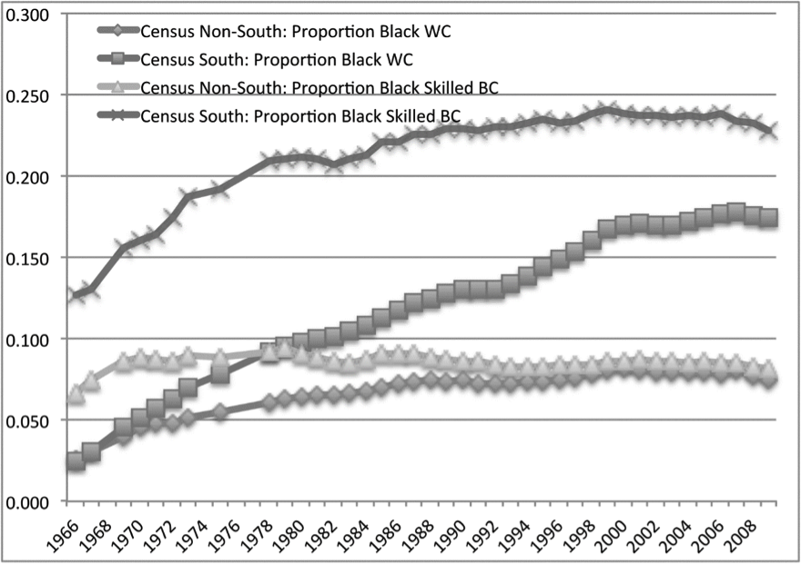

**Source:** EEOC EEO-1 reports. Observations for 1966-1970 are taken from the annual EEOC publication Job Patterns for Minorities and Women in Private Industry. Blue-Collar occupations include both operative and skilled crafts, excluding laborer and service jobs.

Much of this came to an end with the dramatic “regime change” in federal racial employment policies after the election of Ronald Reagan in 1980.[79] The effect was not quite immediate, because the administration’s early statements were often ambiguous, and federal budgetary changes take time in any case. But real budget appropriations and staffing were clearly headed downward after 1981, at both the EEOC and the OFCCP. Perhaps even more important than resources were the policy shifts by officials. Newly appointed EEOC Director Clarence Thomas directed the agency’s general counsel not to approve conciliation agreements that included employment goals and timetables.[80] Ellen M. Shong, the new director of the OFCCP, pledged that her office intended to “open doors and not close contracts” as part of a policy shift towards relaxed regulatory activity.[81] William Bradford Reynolds, Assistant Attorney General for Civil Rights, stated his support for “individual opportunity” as opposed to “group entitlements,” specifically opposing “race-conscious affirmative action.”[82] The administration was true to these words. EEOC cases recommended to the General Counsel and lawsuits filed each fell by 50 percent.[83] More importantly, the agency ceased its efforts to identify patterns of bias in industries or firms and no longer pursued class action suits, concentrating instead on individual discrimination complaints.[84] Compliance reviews by the OFCCP actually increased but became perfunctory, rarely imposing penalties. Jonathan Leonard, the foremost economic analyst of anti-discrimination programs, concluded that “affirmative action under the contract compliance program virtually ceased to exist in all but name after 1980.”[85]

Did this major policy shift have an effect on real-world outcomes? It would be rash to argue that all or most of the slowdown in black economic progress after 1980 was directly attributable to changes in affirmative action policy, and few if any economists advance this claim. But many experts do argue that the virtual withdrawal of the federal government from active enforcement efforts had deleterious consequences, which were especially damaging in combination with adverse developments in labor markets and international manufacturing competition.[86]

Surprisingly, however, in the South the black share of skilled blue-collar jobs resumed its growth after 1982, and the black share of white-collar positions continued to rise steadily through the 1990s, and more moderately thereafter (Figure 3). This is not a simple matter of adjustment to racial demographics, or of regional “convergence” in degrees of representation. When the figures are normalized to reflect regional or metropolitan differences in black population shares, the distinctiveness of the southern track record stands out even more clearly.

Perhaps the best evidence for the reality of black occupational progress in the South has been the reversal of migration patterns that had prevailed for more than a century. Since 1970, net black migration has been persistently southward, increasingly so over time. Between 1980 and 2010 more than 1.5 million African Americans moved south from all other regions of the country.[87] Demographic studies show that although the South attracted a larger absolute number of white migrants, blacks in other regions were substantially more likely than whites to choose the South as their destination. This “reverse” black migration into the South was highly selective both on education and stable family structure, relative to black movers elsewhere.[88]

We do not yet know all of the reasons for this pattern, but the list of likely factors includes: economic growth in southern cities with large black populations; “network effects” associated with historically black southern communities; greater black political representation in the South; the impact of black representation on recruitment and retention of new black employees. Particularly suggestive are studies showing that the variable most strongly related to new black employment is the percentage of job applicants who are African-American, in turn strongly influenced by the race of the hiring officer.[89] One exceptional study was able to exploit manager turnover at a large U.S. retail firm to isolate the effect of the hiring officer’s race or ethnicity on the race or ethnicity of new hires. The authors found not only that own-race hiring bias was significant, but that these effects were most pronounced in the South.[90]

What we can say with more confidence is that these advances have not been driven by increasingly forceful applications of Title VII to private employers in the South. Historical analyses of employment litigation have shown that racial employment discrimination cases sharply declined relative to other types of employment issues as of the 1980s.[91] Evidently enactment and early enforcement of Title VII launched a dynamic that has continued long after the Civil Rights era, but only in the South. This record is testimony, on the one hand, to the historic impact of the law. On the other, it stands as a refutation of the notion that the nation has moved beyond race consciousness in employment as in other realms of life.

Conclusion

The Civil Rights Act of 1964 was primarily prompted by the race issue in the South. In this realm, it was a great success, generating lasting gains for African-Americans through major reductions in racial exclusions and inequities, with few signs of significant inefficiencies in the process. These accomplishments did not simply flow as consequences from passage of the Act, but required ongoing moral and political pressure from the Civil Rights Movement, plus mutually supportive enforcement efforts from several bases in the federal government. Bringing important interest groups around to understanding that the Civil Rights revolution served their economic interests as well was also important for the legislation’s success. These accomplishments were by no means limited to the South, but black economic progress in other regions proved more vulnerable to changes in prevailing judicial philosophies in the wake of the regime change in national politics after 1980.

What the Civil Rights Act did not do is create a post-racial society. Title VII prohibits discrimination by race or color, yet progress did not come mainly from ignoring race but by taking race systematically into account. The largest and most lasting gains came in a region where racial consciousness remains strong. This uneasy partnership between universalist rhetoric and race-consciousness has been historically productive. But it is difficult to see this formula as the major vehicle in current and future struggles against economic inequality. Racial prejudice and discrimination undoubtedly continue. But they have been overwhelmed by structural changes in the U.S. labor market that could not have been foreseen in 1964.

The principles of Title VII are still important and should clearly be retained. They were extended to women in the original legislation and by subsequent court ruling to sexual harassment. Later legislation extended protected status to age, pregnancy, and disabilities, and we may soon see a further extension to sexual orientation. Individuals in all of these categories deserve protection against discrimination in employment and on the job. But with a majority of the labor force now in protected status, Title VII is not likely in the future to raise the living standards or life prospects of large numbers of low-income Americans, as it did during the Civil Rights era. Nevertheless, if this historical track record does not provide us with a template for the future, it still serves as an inspiration, showing the potential economic value of inclusiveness.

1. *William Robertson Coe Professor of American Economic History, Stanford University. Professor Wright acknowledges helpful comments on the conference paper from Linda McClain, Bruce Schulman, Jenny Bourne, and Sophia Lee, and superb editorial assistance from Michael Tartaglia.
2. Pub. L. No. 88-352, 78 Stat. 241 (codified as amended in scattered sections of 5 U.S.C., 28 U.S.C., and 42 U.S.C.)
3. Clay Risen, The Bill of the Century: The Epic Battle for the Civil Rights Act 2 (2014)
4. *Id.* at 220.
5. 42 U.S.C. § 2000a (2012).
6. *Id.* §§ 2000e to 2000e-17 (2012).
7. *Id.* § 1971 (1964).
8. 42 U.S.C. § 2000f (2012).
9. 42 U.S.C. §§ 1973 to 1973bb-1 (2012).
10. 42 U.S.C. § 2000c (2012).
11. 42 U.S.C. § 2000d (2012).
12. Pub. L. No. 89-10, 79 Stat. 27.
13. Elizabeth Cascio, Nora Gordon, Ethan Lewis, & Sarah Reber, *Paying for Progress: Conditional Grants and the Desegregation of Southern Schools*, 125 Q. J. Econ. 445, 473-74 (2010) (“[M]aking receipt of the substantial new federal funds offered through Title I ESEA contingent on nondiscrimination through the CRA played a role historically in desegregating Southern schools.”).
14. 347 U.S. 483 (1954).
15. Marian A. Wright, *Public Accommodations*, *in* Legal Aspects of the Civil Rights Movement 87-88 (Donald B. King & Charles W. Quick eds., 1965).
16. Ernest M. Limbo, *James Lawson: The Nashville Civil Rights Movement*, *in* The Human Rights Tradition in the Civil Rights Movement 165-66 (Susan M. Glisson, ed., 2006).
17. William H. Chafe, Civilities and Civil Rights: Greensboro, North Carolina, and the Black Struggle for Freedom 136 (1980).
18. Christopher W. Schmidt, *The Sit-ins and the State Action Doctrine*, 18 Wm. & Mary Bill Rts. J. 767, 771 (2010) (“Between 1961 and 1963, the Court found ways to side with the students, overturning trespassing and breach-of-peace convictions on narrow, fact-based grounds, while avoiding the looming constitutional issue.”).
19. *Id.* (Explaining how support for a draft opinion concluding that the Constitution did not require racially integrated public accommodations evaporated with Senate approval of the Civil Rights Act of 1964).
20. Gavin Wright, Sharing the Prize: The Economics of the Civil Rights Revolution in the American South 84-89 (2013) (quoting contemporary interviews with metropolitan business owners expressing surprise and relief at the positive impact of integration on their businesses).
21. Memorandum from Burke Marshall to Robert F. Kennedy 1 (Nov. 13, 1963) (on file with the John F. Kennedy Presidential Library), *available at* http://www.jfklibrary.org/Asset-Viewer/Archives/BMPP-030-006.aspx#, *archived at* http://perma.cc/YT7U-Y76Y.
22. *Id.* at 7.
23. Ivan Allen, Jr. with Paul Hemphill, Mayor: Notes on the Sixties 103 (1971).
24. Wright, *supra* note 7, at 94-95.
25. James C. Tanner, *Civil Rights Test: Negroes in South Ready Immediate, Broad Drive to Try Out New Law*, Wall St. J., July 2, 1964, at 1.
26. *Id.*
27. Richard Seldin, *Eradicating Racial Discrimination at Public Accommodations not Covered by Title II*, 28 Rutgers L. Rev. 1, 4 (1974) (“Recent decisions, however, have rejected this distinction [between spectator- and participant-oriented places of exhibition or entertainment] and have held that roller skating rinks, ‘amusement parks,’ recreational areas, and bars with mechanical entertainment devises are covered as places of entertainment.” (citations omitted)).
28. Lisa Gabrielle Lerman & Annette K. Sanderson, *Discrimination in Access to Public Places*, 7 N.Y.U. Rev. L. & Soc. Change 215 (1978); U.S. Dept. of Justice, Annual Report of the Attorney General,1965-1977*.*
29. Joseph William Singer, *No Right to Exclude: Public Accommodations and Private Property*, 90 Nw. U. L. Rev. 1283 (1996).
30. *Id.* at 1293.
31. Donald Dewey, *Four Studies of Negro Employment in the Upper South*, *in* Selected Studies of Negro Employment in the South 175 (Nat’l Planning Ass’n ed., 1955).
32. Richard L. Rowan, *The Negro in the Textile Industry, Report No. 20*, *in* The Negro in the Textile Industry1 (1970) (“Negroes were excluded from the textile industry, almost as a matter of policy, from 1880 to 1960.”).
33. William J. Collins, *Race, Roosevelt, and Wartime Production: Fair Employment in World War II Labor Markets*, 91 Am. Econ. Rev. 272, 284 (2001) (“The FEPC . . . was surprisingly effective in its efforts to promote Roosevelt’s antidiscrimination policy outside of the South, though the Committee appears to have been powerless in the South.”); William J. Collins, *The Labor Market Impact of State-Level Anti-Discrimination Laws*, 1940-1960, 56 Indus. & Lab. Rel. Rev. 244, 244-72 (2003).
34. *See, e.g.*, Jacob Perlman & Edward K. Frazier, *Entrance Rates of Common Laborers in 20 Industries, July 1937*, 45 Monthly Lab. Rev. 1491, 1494 (1937) (showing no difference in average entry-level compensation for white and black common laborers in non-southern states).
35. Jenny Bourne, *“A Stone of Hope”: The Civil Rights Act of 1964 and Its Impact on the Economic Status of Black Americans*, 74 La. L. Rev. 1195, 1215 (2014); William A. Sundstrom, *Last Hired, First Fired? Unemployment and Urban Black Workers in the Great Depression*, 52 J. Econ. Hist. 415-429 (1992) (discussing black unemployment rates in the 1930s); Christopher L. Foote, Warren C. Whatley, & Gavin Wright, *Arbitraging a Discriminatory Labor Market: Black Workers at the Ford Motor Company, 1918-1947*, 21 J. Lab. Econ. 493, 493-532 (2003) (explaining job assignments and the absence of a racial wage differential in the auto industry).
36. William P. Jones, The March on Washington: Jobs, Freedom, and the Forgotten History of Civil Rights 163-74 (2013) (describing how northern activists expanded plans for a proposed March on Washington for Jobs to include demands for expanded protection of civil liberties in order to accommodate southern activists).
37. Exec. Order No. 10,925, 3 C.F.R. 448, 450 (1959-1963).
38. Memorandum from Burke Marshall to Robert F. Kennedy (March 2, 1963) (on file with the John F. Kennedy Presidential Library), *available at* http://www.jfklibrary.org/Asset-Viewer/Archives/BMPP-008-001.aspx#.
39. 42 U.S.C. § 2000e-2(h) (2012).
40. Daniel B. Rodriguez & Barry R. Weingast, *The Positive Political Theory of Legislative History: New Perspectives on the 1964 Civil Rights Act and Its Interpretation*, 151 U. Pa. L. Rev. 1417, 1492-96 (2003) (arguing that Senator Dirksen blunted the impact of the 1964 CRA on Northern states in order to attract Republican support necessary to defeat a filibuster of the Act).
41. Charles Brown, *The Federal Attack on Labor Market Discrimination: The Mouse that Roared?*, 5 Res. Lab. Econ. 33, 33 (1982) (“In general, time series studies find significant improvements in the relative labor market position of blacks compared with whites since 1965.”); Richard B. Freeman, *Black Economic Progress after 1964: Who Has Gained and Why?*, *in* Studies in Labor Markets247, 247 (Sherwin Rosen ed. 1981) (“[B]lack Americans made substantial advances in the job market after 1964. . . .”); Richard B. Freeman, R. A. Gordon, Duran Bell & Robert E. Hall, *Changes in the Labor Market for Black Americans, 1948-1972*, Brookings Papers on Econ. Activity 67-131 (1973); Wayne Vroman, *Changes in Black Workers’ Relative Earnings: Evidence from the 1960s*, *in* Patterns of Racial Discrimination 167, 187 (George M. von Furstenberg et al. eds., 1974) (concluding that census data showed “evidence of a post-1964 acceleration of earnings gains for blacks”).
42. John J. Donohue III & James J. Heckman, *Continuous Versus Episodic Change: The Impact of Civil Rights Policy on the Economic Status of Blacks*, 29 J. Econ. Literature 1603-43 (1991); Vroman, *supra* note 40, at 181-84; Bourne, *supra* note 34, at 1205-09.
43. William J. Carrington, Kristin McCue & Brooks Pierce, *Using Establishment Size to Measure the Impact of Title VII and Affirmative Action*, 35 J. Hum. Resources 503, 504-14 (2000); Kenneth Y. Chay, *The Impact of Federal Civil Rights Policy on Black Economic Progress*, 51Indus. Lab. Rel. Rev. 608, 611-12 (1998).
44. Joni Hersch & Jennifer Bennett Shinall, *Fifty Years Later: The Legacy of the Civil Rights Act of 1964*, at 13-21 (Vand. U. L. Sch. L. & Econ. Working Paper No. 14-33, 2014); David Neumark & Wendy A. Stock, *The Labor Market Effects of Sex and Race Discrimination Laws*, 44 Econ. Inquiry 385, 387-89 (2006).
45. Richard J. Butler, James J. Heckman, & Brook Payner, *The Impact of the Economy and the State on the Economic Status of Blacks: A Study of South Carolina*, *in* Markets in History 231, 247-50 (David Galenson ed., 1989) (discussing previous research by Alice E. Kidder and concluding that “government policy played a significant role in improving black economic status . . . rather than merely reflecting changes that were already taking place.”).
46. David Card & Alan B. Krueger, *School Quality and Black-White Relative Earnings: A Direct Assessment*, 107 Q. J. Econ. 151, 168 (1992) (showing clear improvements in common metrics of black school-quality from 1920-1960).
47. 163 U.S. 537 (1896) (finding segregation constitutional under the principle of “separate but equal”).
48. John J. Donohue III, James J. Heckman, & Petra Todd, *The Schooling of Southern Blacks: The Roles of Legal Activism and Private Philanthropy, 1910-1960*, 117 Q. J. Econ*.* 225, 236-51 (2002); Daniel Aaronson & Bhashkar Mazumder, *The Impact of Rosenwald Schools on Black Achievement*, 119 J. Pol. Econ. 821, 821-88 (2011).
49. Card & Krueger, *supra* note 45, at 153, 164-65 (compiling cross-tabulation data and concluding that “the rise in the return to education for Southern-born blacks was driven by improvements in the quality of black schools, and not simply by an economywide reduction in discrimination against better-educated black workers.”). For the black cohort born between 1940 and 1949, the sharpest increase in returns to education was for those *residing* in the South, whether northern-born or southern-born. Indeed, the increase was greater for the northern-born. Thus the evidence suggests that the crucial locus of change during the 1960s and 1970s was labor markets in the South.
50. Wright, *supra* note 19 at 133 (compiling census data showing “little to no progress in [black occupational status] in the 1950s” in three large Southern cities and in the region as a whole).
51. Wright, *supra* note 19, at 105.
52. Glenn T. Eskew, But for Birmingham: The Local and National Movements in the Civil Rights Struggle 199 (1997).
53. Wright, *supra* note 19, at 138-39.
54. *See, e.g.*, Bruce J. Schulman, The Seventies: The Great Shift in American Culture, Society, and Politics (2001).
55. 3 C.F.R. 339 (1964-1965).
56. Jonathan S. Leonard, *The Impact of Affirmative Action on Employment*, 2 J. Lab. Econ. 439, 446-51 (1984); Jonathan S. Leonard, *Employment and Occupational Advance Under Affirmative Action*, 66 Rev. Econ. & Stat. 377-85 (1984).
57. Jonathan S. Leonard, *Antidiscrimination or Reverse Discrimination: The Impact of Changing Demographics, Title VII, and Affirmative Action on Productivity*, 19 J. Hum. Resources 145, 147-55 (1984).
58. Mary Fredrickson, *Four Decades of Change: Black Workers in Southern Textiles, 1918-1981*, *in* Workers’ Struggles, Past and Present 62, 73 (James Green ed., 1983).
59. Wright, *supra* note 19, at 112.
60. Roy Reed, *Industry in South Woos Negro Labor*, N.Y. Times, May 19, 1969, at A1.
61. 401 U.S. 424 (1971).
62. *Id.* at 426.
63. Robert Belton, The Crusade for Equality in the Workplace: The Griggs v. Duke Power Story 109 (2014).
64. *Griggs*, 401 U.S. at 431 (“The [Civil Rights] Act proscribes not only overt discrimination but also practices that are fair in form, but discriminatory in operation.”). *See generally* Belton, *supra* note 62; Robert Samuel Smith, Race, Labor and Civil Rights: Griggs versus Duke Power and the Struggle for Equal Employment Opportunity (2008).
65. Alfred W. Blumrosen, *The Legacy of* Griggs*: Social Progress and Subjective Judgments*, 63 Chi. Kent L. Rev. 1, 11 (1987).
66. John David Skrentny, The Ironies of Affirmative Action: Politics, Culture, and Justice in America 121-33 (1996)).
67. Belton, *supra* note 62, at 171.
68. Nicholas Pedriana & Robin Stryker, *The Strength of a Weak Agency: Enforcement of Title VII of the 1964 Civil Rights Act and the Expansion of State Capacity, 1965-1971*, 110 Am. J. Soc. 709, 745-47 (2004).
69. Skrentny, *supra* note , at 133-139.
70. Erin Kelly & Frank Dobbin, *How Affirmative Action Became Diversity Management*, *in* Color Lines: Affirmative Action, Immigration, and Civil Rights Options for America 91-92 (John David Skrentny ed., 2001).
71. Frank Dobbin, Inventing Equal Opportunity 158 (2009).
72. Anne B. Fisher, *Businessmen Like to Hire by the Numbers*, Fortune, September 16, 1985, at 26 (“[P]ersuasive evidence indicates that most large American corporations want to retain their affirmative action programs, numerical goals and all.”).
73. Jerome M. Culp, *A New Employment Policy for the 1980s: Learning from the Victories and Defeats of Twenty Years of Title VII*, 37 Rutgers L. Rev. 889, 899 (1985).
74. Belton, *supra* note 62 at 33.
75. Alfred W. Blumrosen, *The Law Transmission System and the Southern Jurisprudence of Employment Discrimination*, 6 Indus. Rel. L. J. 313, 316, 352 (1984).
76. Butler et al, *supra* note , at 233-234 (showing that relative black wage growth between 1960-70 was due largely to a shift in occupation from lower- to higher-paying job types).
77. Konrad Mark Hamilton, From “Equal Opportunity” to “Affirmative Action”: A History of the Equal Employment Opportunity Commission, 1965-1980 151-54 (May 1998) (unpublished Ph.D. dissertation, Stanford University) (on file with the Stanford University Special Collections and University Archives).
78. *See, e.g.*, Herbert Hammerman, A Decade of New Opportunity: Affirmative Action in the 1970s (1984).
79. The discussion in this section regarding the “regime change” under President Reagan draws upon forthcoming research in collaboration with Zoë Cullen, a Ph.D. student at Stanford University.
80. Alfred W. Blumrosen, Modern Law: The Law Transmission System and Equal Employment Opportunity 269-70 (1993) (“The EEOC *official* position remained the same in the Reagan Administration as it had been in earlier administrations. However, Chair [Clarence] Thomas informally advised his acting general counsel not to approve agreements which contained goals and timetables.”).
81. Howell Raines, *Reagan Sends Mixed Signals on Civil Rights*, N.Y. Times, July 16, 1981, at A1.
82. Terry H. Anderson, The Pursuit of Fairness: A History of Affirmative Action 169 (2004).
83. *Compare* EEOC, 16th Annual Report 29 (1981) (showing 307 Title VII cases recommended to the General Counsel), *with* EEOC, 19th Annual Report 17 (1984) (showing 162 Title VII cases recommended to the General Counsel).
84. Anderson, *supra* note , at 178 (“[T]he EEOC [during the Reagan Administraton] no longer attempted to identify patterns of bias throughout industries or in companies, and no longer pursued class-action suits.”).
85. Jonathan S. Leonard, *The Impact of Affirmative Action Regulation and Equal Employment Law on Black Employment*, 4 J. Econ. Persp. 47, 58 (1990).
86. *See* John Bound & Richard B. Freeman, *What Went Wrong? The Erosion of Relative Earnings and Employment Among Young Black Men in the 1980s*, 107 Q. J. Econ. 201, 228-29 (1992) (“[Government pressures to increase minority employment lessened in the 1980s . . . . [T]here is reason to expect that [this] contributed to the observed erosion of gains [in minority employment.”).
87. Wright, *supra* note , at 142-46.
88. William H. Frey, *The New Great Migration: Black Americans’ Return to the South, 1965-2000*, *in* Redefining Urban and Suburban America, Volume Two 87, 95-100 (Alan Berube, Bruce Katz & Robert E. Lang eds., 2005) (“More educated blacks are now migrating to Southern destinations at higher rates than those with lower education levels.”); Larry L. Hunt, Matthew O. Hunt & William W. Falk, *Who Is Headed South? U.S. Migration Trends in Black and White, 1970-2000*, 87 Soc. Forces 95, 103-10 (2008) (analyzing data showing that married blacks moved to the south at much higher rates than married blacks in the south moved elsewhere); Matthew O. Hunt, Larry L. Hunt & William W. Falk, *“Call to Home?” Race, Region, and Migration to the U.S. South, 1970-2000*, 27 Soc. Forum 117, 126-36 (2012) (analyzing the status advantages of blacks who migrated to the South relative to blacks who migrated outside of the South).
89. Michael A. Stoll, Steven Raphael & Harry J. Holzer, *Black Job Applicants and the Hiring Officer’s Race*, 57 Indus. & Lab. Rel. Rev. 267, 283-84 (2004) (finding that “the propensity of blacks to apply for jobs in the establishments where blacks occupy positions of authority” contributed significantly to the likelihood of employers with African American hiring agents to hire blacks).
90. Laura Giuliano, David I. Levine & Jonathan Leonard, *Manager Race and the Race of New Hires*, 27 J. Lab. Econ. 589, 626 (2009). *See also* Laura Giuliano, David I. Levine & Jonathan Leonard, *Racial Bias in the Manager-Employee Relationship: An Analysis of Quits, Dismissals and Promotions at a Large Retail Firm*, 46 J. Hum. Resources 26, 30, 50-51 (2011).
91. Sara Wakefield & Christopher Uggen, *The Declining Significance of Race in Federal Civil Rights Law: The Social Structure of Employment Discrimination claims,* 74 Soc. Inquiry 128, 131 (2004) (showing a sharp decline in the percentage of EEOC employment discrimination complaints filed on the basis of race), *available at* http://www.socsci.umn.edu/~uggen/Wakefield_Uggen_SI.pdf, *archived at* http://perma.cc/9ETV-XAVT . *See also* John J. Donohue III & Peter Siegelman, *The Changing Nature of Employment Discrimination Litigation*, 43 Stan. L. Rev. 983 (1991).